Prepositions of TIME and PLACE
(IN/ ON/ AT)

IN/ ON/ AT: Prepositions of Time

IN
The preposition IN is used for non-specific times, for example: years, months
In + Parts of the day
- In the morning
- In the afternoon
- In the evening
In + Months
- In January
- In February
In + Seasons
- In (the) spring
- In (the) summer
In + Years
- In 1986
- In 1976
- In 1991
In + Decades
- In the 1960s
- In the seventies
In + Centuries
- In the 15th century
- In the 21st century
In + Weeks
- In a week
- In 2 weeks
In + Periods of time
- In the past
- In the next century
- In the future
- In the middle ages
- In a moment

In + Holidays
- In the Easter holiday

ON
The preposition of time ON is used for dates, days of the week and holidays with “day”
On + Days
- On Monday
- On Thursday
- On Sunday

On + Dates

- On April 3rd
- On 1st January 2013
- On the 10th
- On the first day

On + Holidays with “day”

- On New Year’s day
- On Christmas day
- On Easter day

On + Specific days
Examples:
- On my birthday
- On my wedding day
- On that day

On + Time

- [On the weekend (U.S.)]
- On weekdays
- On time
- On a summer evening

On + Day + Part of day
- On Sunday morning(s)
- On Friday afternoon(s)
- On Monday evening(s)

AT
The preposition AT is used for specific times and holidays without “day”
At + Hours
- At 7 am
- At 12 o’clock

At + Parts of the day
- At night
- At noon/ midday
- At midnight

At + Holidays without “day”
- At Easter
- At Christmas
- At New Year
At + Time
- At present
- At the weekend (U.K)
- At breakfast
- At the moment

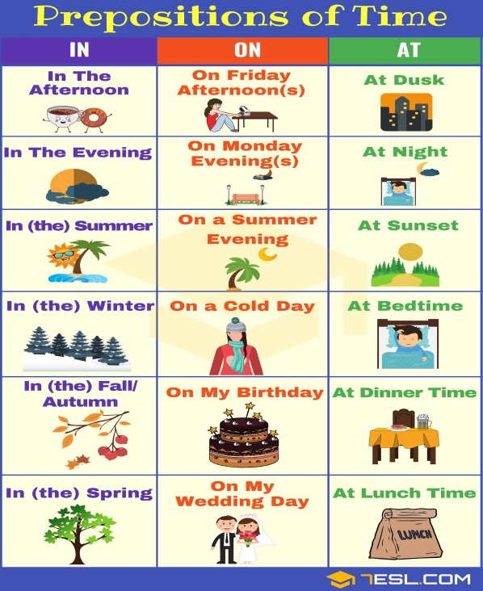

IN/ ON/ AT: Prepositions of Place

IN
For describing place, the preposition IN is used for the largest or most general places. You can say that “I lived in London as a child.” And “He’s a very famous person in Chinatown.”

In + Countries

- In England
- In America

In + Cities

- In London
- In New York

In + Neighbourhood
- In Manhattan
- In Chinatown

In + Enclosed Space
- In a traffic jam
- In a building
- In a car

ON
The preposition of place ON is used for more specific places, like certain streets. You can say that “He took a northbound trolley on State Street.”

On + Means of transport
- On a bus
- On a train
- On a plane

On + Communications
- On the radio
- On the television
- On the phone
- On the Internet

On + Surfaces
- On a table
- On a wall
- On the floor
- On the roof
- On the ceiling

AT
The preposition AT is used in the following descriptions of place/position

At + Exact Addresses or Intersections
- At 23 Birch Street
- At 734 State Street

At + Specific Locations/ Points
- At The Empire State Building
- At the corner
- At the bus stop

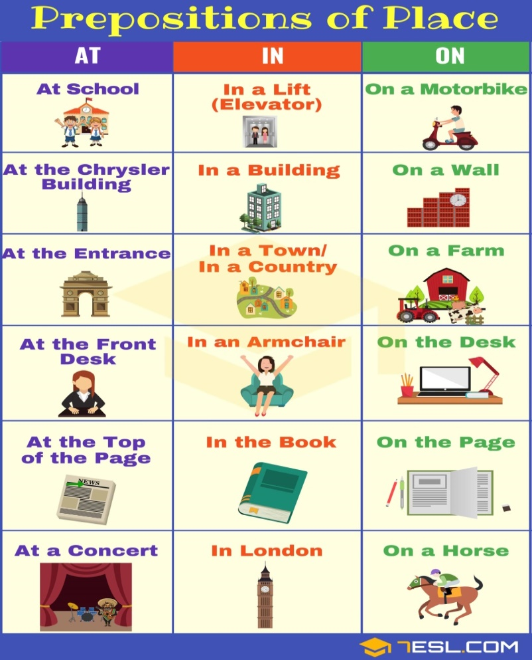

IN/ ON/ AT: Prepositions of TIME and PLACE
How to Use Prepositions of TIME and Prepositions of PLACE Correctly

